**Opening a New Shopping Mall in Chennai, India**

M S Ishwarya

27-Nov-2019

1. **Introduction:**

This document discusses on the background of the problem, problem of interest, proposed solution to the problem, potential stake holder and data required for the proposed solution

**1.1 Problem Background:**

Whenever investor or property developers invest on a venue they wish invest in the location that the city can best offer. This is particularly important since the stake holders would want to know how impact the venue is given the project is successfully launched. Further, it is critical to choose the best place among many candidate locations for launching. On the other hand, it is a trend in metropolitan cities that places that solve people’s entertainment and shopping need are highly impactful, in particular, shopping mall.

This capstone has chosen metropolitan city – Chennai for further analysis. Chennai is non-uniformly distributed city in term of density of population as well as importance. Further, the existing shopping malls are non-uniformly distributed as well. Considering all these, we should select a venue for launching a shopping mall.

**1.2 Problem statement:** Finding a suitable location in Chennai, India for opening a shopping mall.

1. **Target Audience of this project:** Target audience of this project can be two folds a) property developers and investors b) Retailers/ vendors who wish to have a franchise in the mall to be launched. Property developers and investors who wish to invest a venue that has high return of investment would like to know the results of this analysis. Also, retailers who wish to increase their profit for retail store in mall would like to know the results of this analysis.

1. **Data:**  In order to understand and identify the prime locations in Chennai that will huge impact, it is important to analyse its neighbourhoods first.
   1. **Wikipedia:** List of neighbourhoods in Chennai. Link to source: <https://en.wikipedia.org/wiki/Category:Neighbourhoods_in_Chennai>
   2. **GeoPy:** Further, these neighbourhoods are analysed based on the geographical coordinates that are inside certain radius. For this, we make use of Geopy package.
   3. **Four Square API:** These coordinates based neighbourhoods are further analysed from the perspective of venues, in particular, shopping mall. For this, we make use of Four Square API.
2. **Proposed Methodology:** These venue and coordinate based neighbourhoods are clustered for similarities and difference in their nature. For the purpose of clustering, we make use of K-Means clustering algorithm. From the resultant clustered neighbourhoods, an appropriate cluster is chosen for launching the shopping mall. In particular, the proposed methodology regarded for this project can be illustrated using the following steps
   1. Collecting Data regarding the neighbourhoods in Chennai (Source- Wikipedia)
   2. Collecting the geographical coordinates based information of the neighbourhoods in Chennai (Source- Geopy)
   3. Selecting all the neighbourhoods with a specified radius
   4. Identification of all types of venues with that radius
   5. Identification of shopping malls with in the radius
   6. Clustering the neighbourhoods based on the distribution of shopping malls in them
   7. Find the best cluster that illustrates the potentiality of neighbourhood
   8. Provide recommendation
3. **Results:**

Following is the result of the clustering based analysis of the neighbourhoods in Chennai. It can be observed from the map there are three clusters colour coded with three different colours are being illustrated. Among the three clusters, violet and blue shaded cluster are most preferable locations where there are existing well-functional shopping malls.

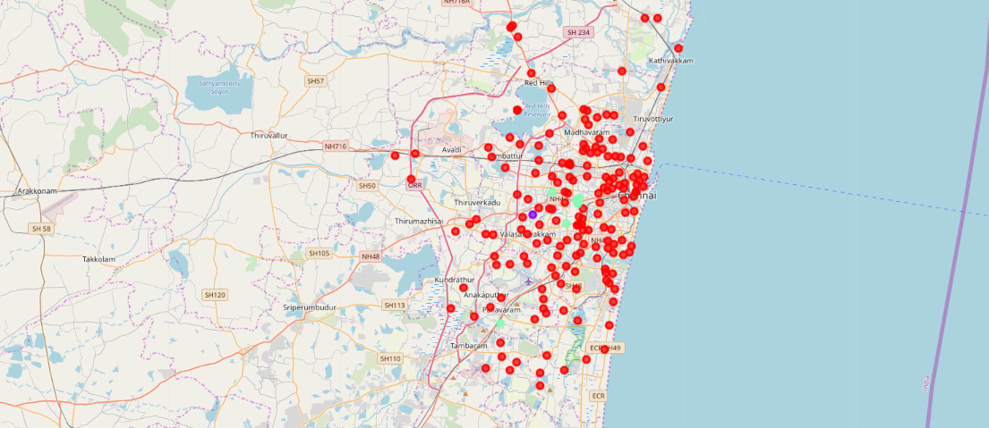

**Figure 1: Cluster based illustration of three groups of neighbourhoods in Chennai**

**suitable for shopping mall**

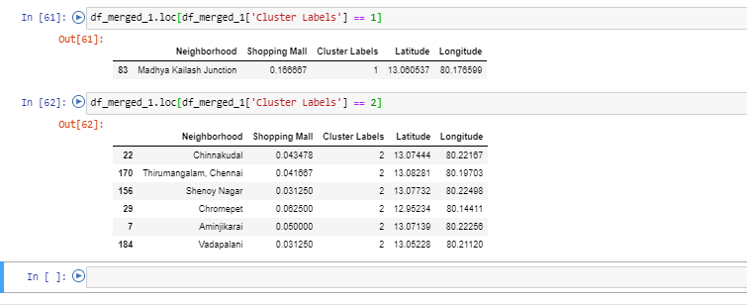

**Figure 2: Most potential locations for shopping mall project**

1. **Discussions:**

The most potential locations for launching a shopping mall project are shown in Figure 2.

First choice: Madhya Kailash Junction (cluster 1)

Second choice: Chinnakudal/ Thirumangalam/ Shanoy Nagar/ Chromepet/ Aminjikari/ Vadapalani (cluster 2)

1. **Conclusions:**

Cluster no. 1 (Madhya Kailash Junction) is the most potential candidate for launching a shopping mall considering its neighbourhoods impact and geographical coordinates.